**201635833 Lee SungMin**

**EX_1 Check Prime Number :**

**Source code :**

import math  
def isPrime(num):  
 MaxRange = math.sqrt(num)  
 MaxRange = math.ceil(MaxRange)  
 for i in range(2,MaxRange+1):  
 if int((num%i)==0):  
 return i  
  
 return num  
  
inputNum = int(input("Type any integer number : "))  
  
if inputNum<2 or inputNum>32767:  
 print("out of range")  
 inputNum = int(input("Type any integer number : "))  
  
  
  
  
if isPrime(inputNum) == inputNum:  
 print('This number is Prime number')  
else :  
 print('This number is not Prime number')

**Source code outcome screenshot :**

**1.**

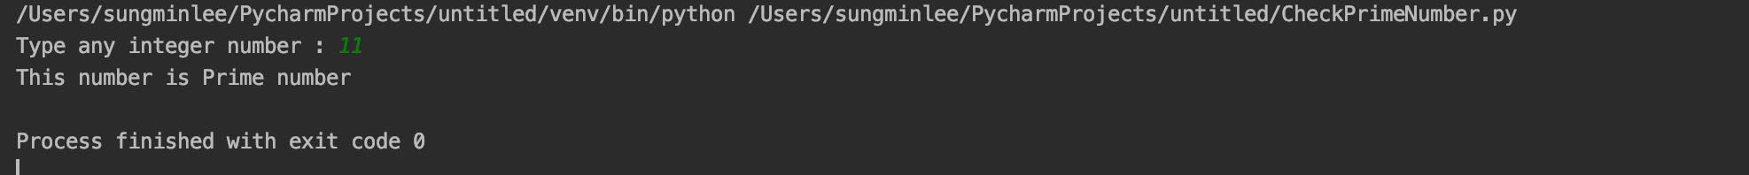

**2.**

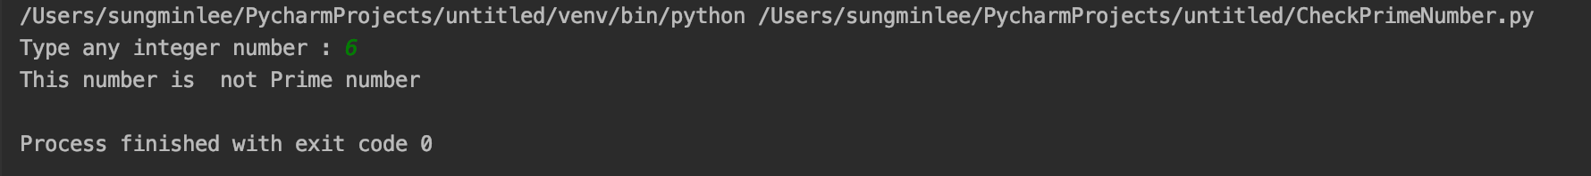

**EX_2 Dictionary Generation :**

**Source code :**

#make dictionary data set and return result

def makeDic(K,V):  
 d = dict()  
 for i in range(0,len(K)):  
 d[K[i]] = V[i]  
 return d  
#check if every key value obtain value from ‘V’ set  
def checkKey(K,V,D):  
 for i in range(0,len(D)):  
 if D[K[i]] != V[i]:  
 return False  
 return True  
K = ['Korean','Mathmetics','English']  
V = [90.0,81.5,91.2]  
D = makeDic(K,V)  
if checkKey(K,V,D):  
 print(D)  
 print('All key obtain value from V')  
else :  
 print('Some key does not obtain right value form V ')

**Source code outcome screenshot :**

